**FUNCTIONS (PART 1 BASICS)**

**LAB # 6**



**Spring 2022**

**CSE102L Computer Programming Lab**

Submitted by: **Ali Asghar**

Registration No. : **21PWCSE2059**

Class Section: **C**

“On my honor, as student of University of Engineering and Technology, I have neither given nor received unauthorized assistance on this academic work.”

Student Signature: ______________

Submitted to:

**Engr. Abdullah Hamid**

July 4, 2022

Department of Computer Systems Engineering

University of Engineering and Technology, Peshawar

**Lab Objective(s)**

* To understand function programming, its types and function-call.

**TASK # 1:**

**Title:**

Write a program that takes marks and registration number as………registration number using function.

**CODE SCREENSHOTS:**

Here are the screenshots of the code.

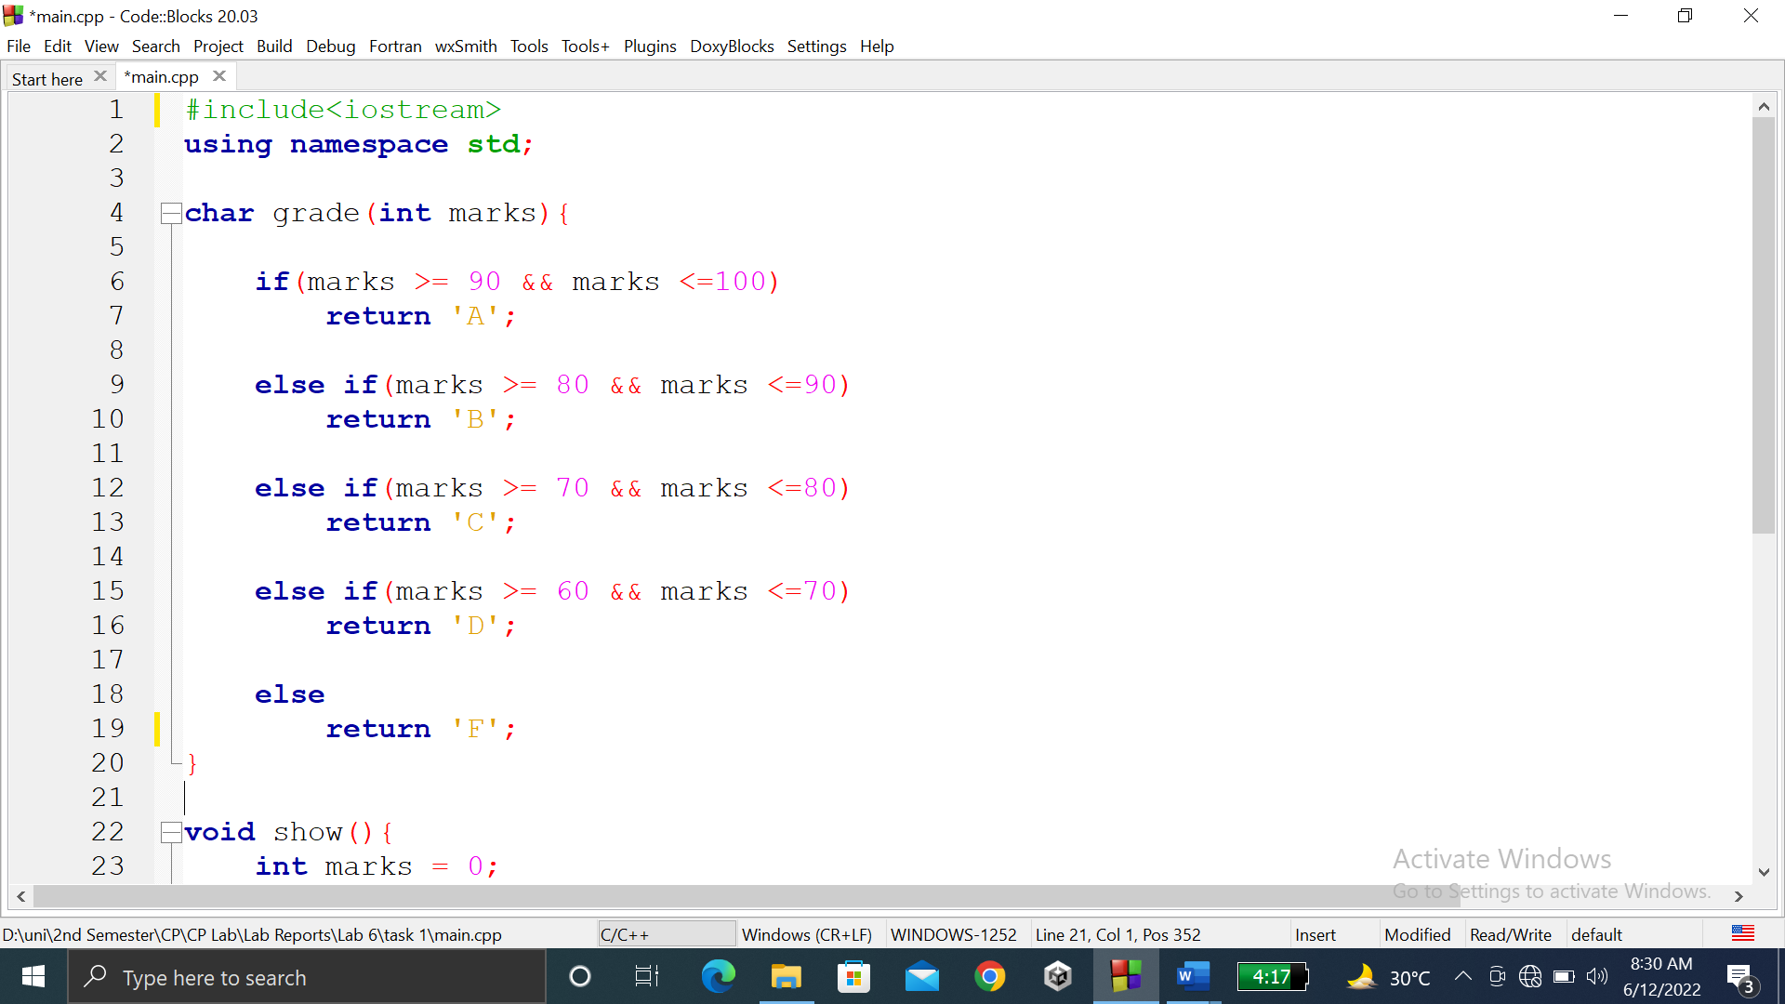

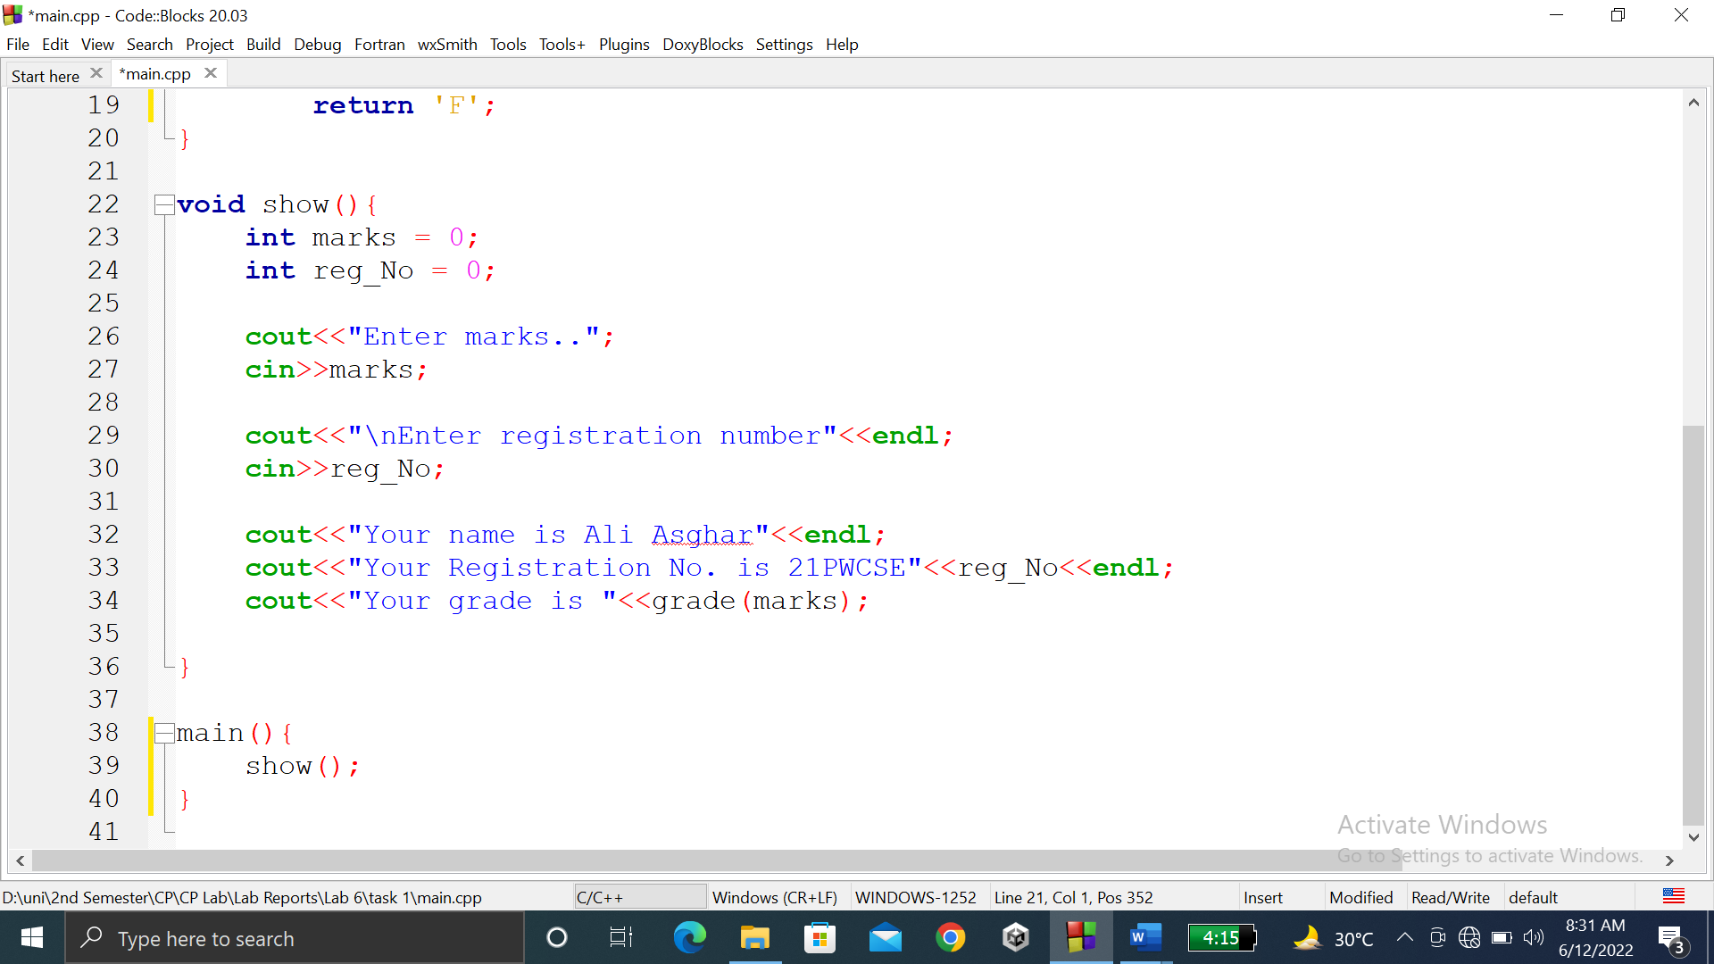

### **OUTPUT (COMPILATION, DEBUGGING & TESTING):**

Here is the screenshot of the output of above code.

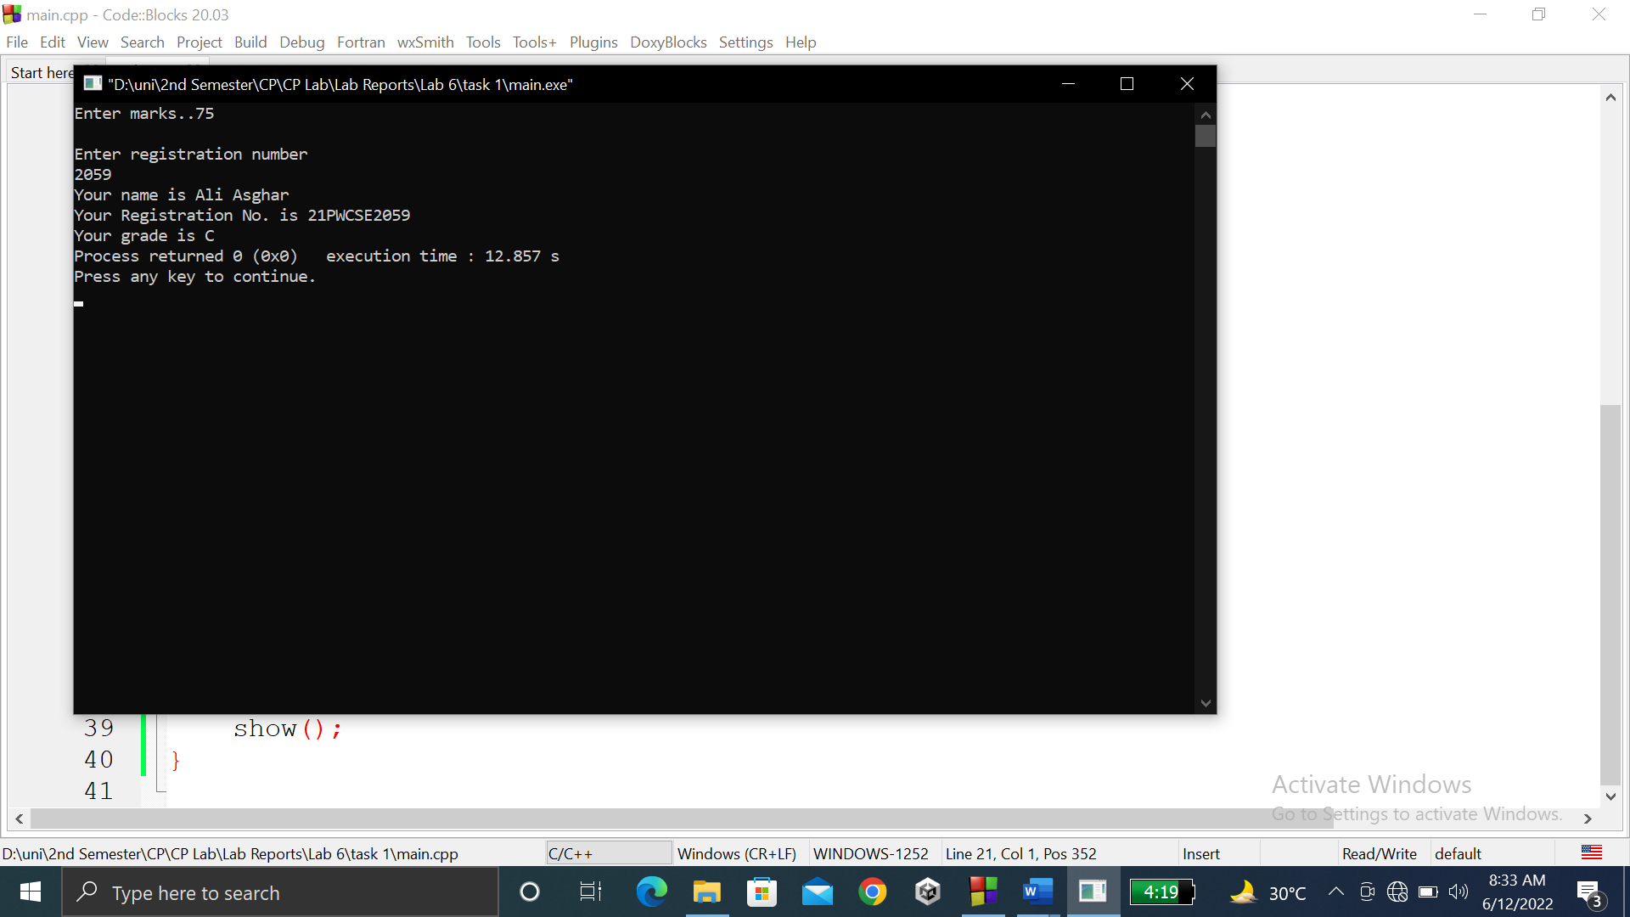

**TASK # 2:**

**Title:**

Write a function minmax () that takes four integers as input and display ……………number.

**CODE SCREENSHOTS:**

Here are the screenshots of the code.

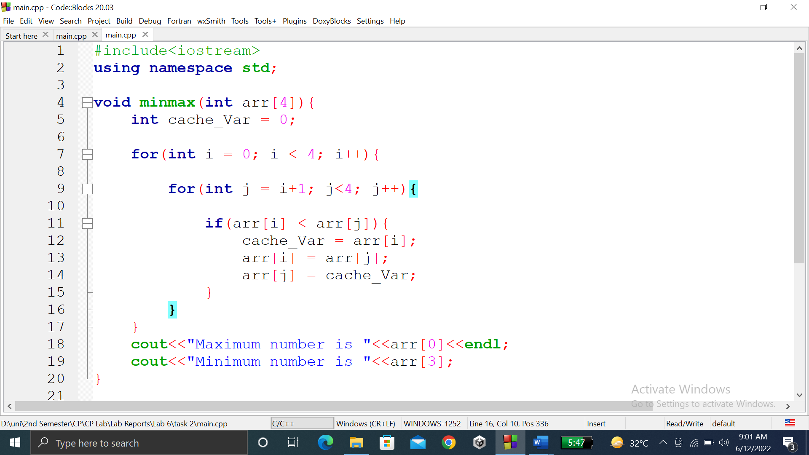

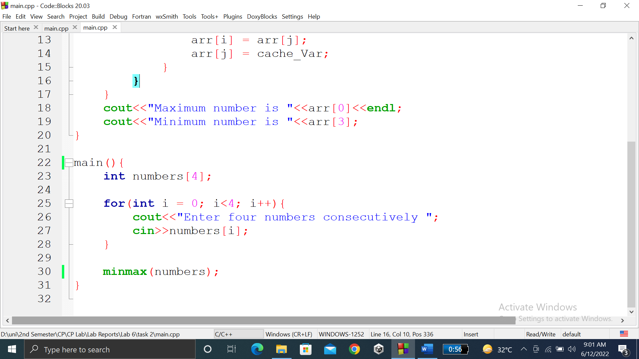

### **OUTPUT (COMPILATION, DEBUGGING & TESTING):**

Here is the screenshot of the output of above code.

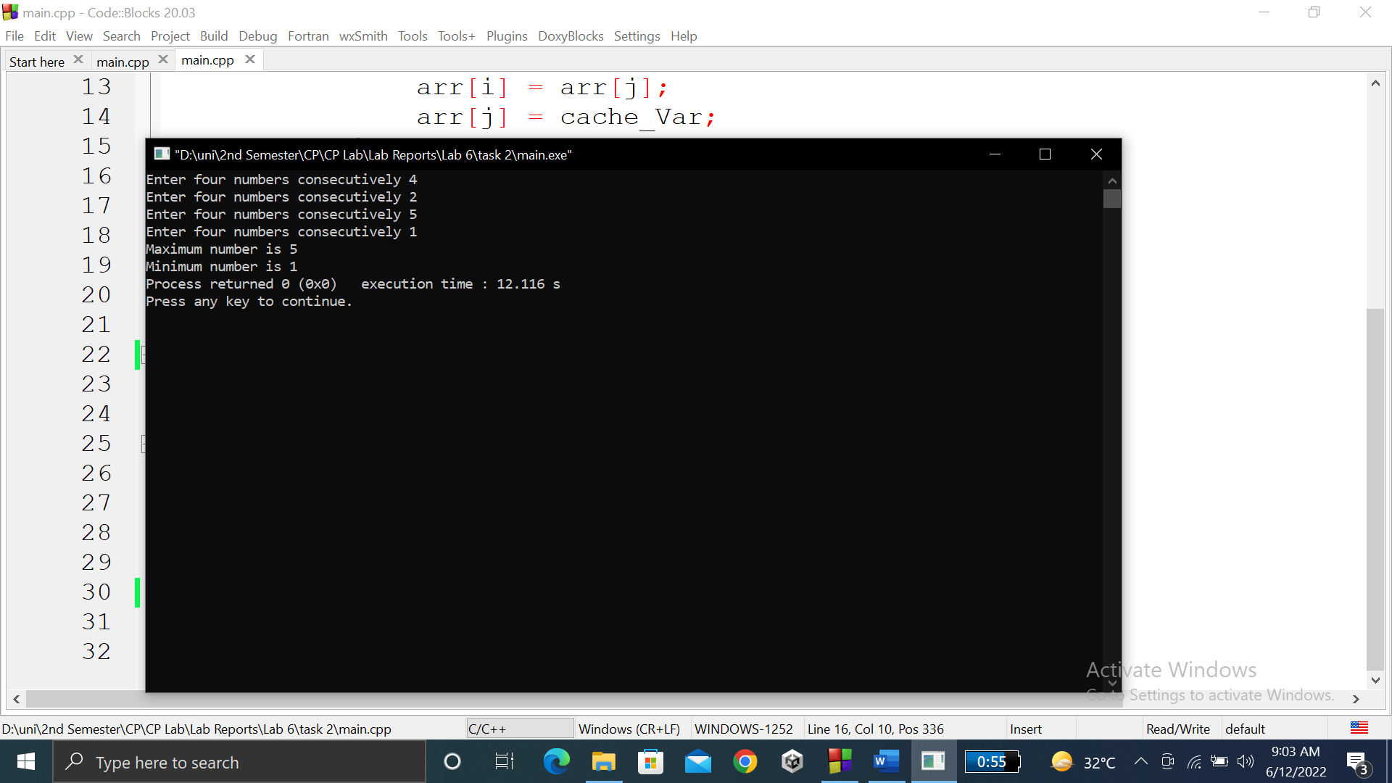

**TASK # 3:**

**Title:**

Your program should have a function named ‘prime’ which accepts an……….Return type bool function

**CODE SCREENSHOTS:**

Here is the screenshot of the code.

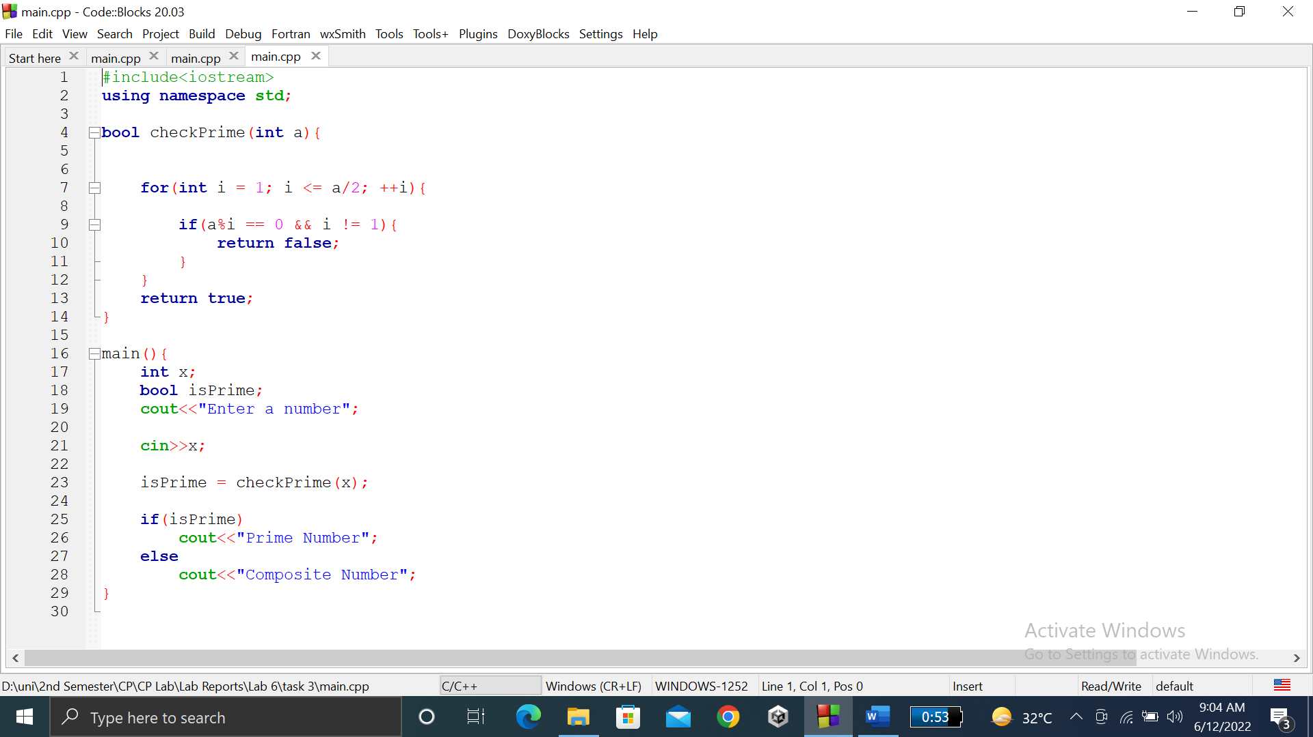

### **OUTPUT (COMPILATION, DEBUGGING & TESTING):**

Here is the screenshot of the output of above code.

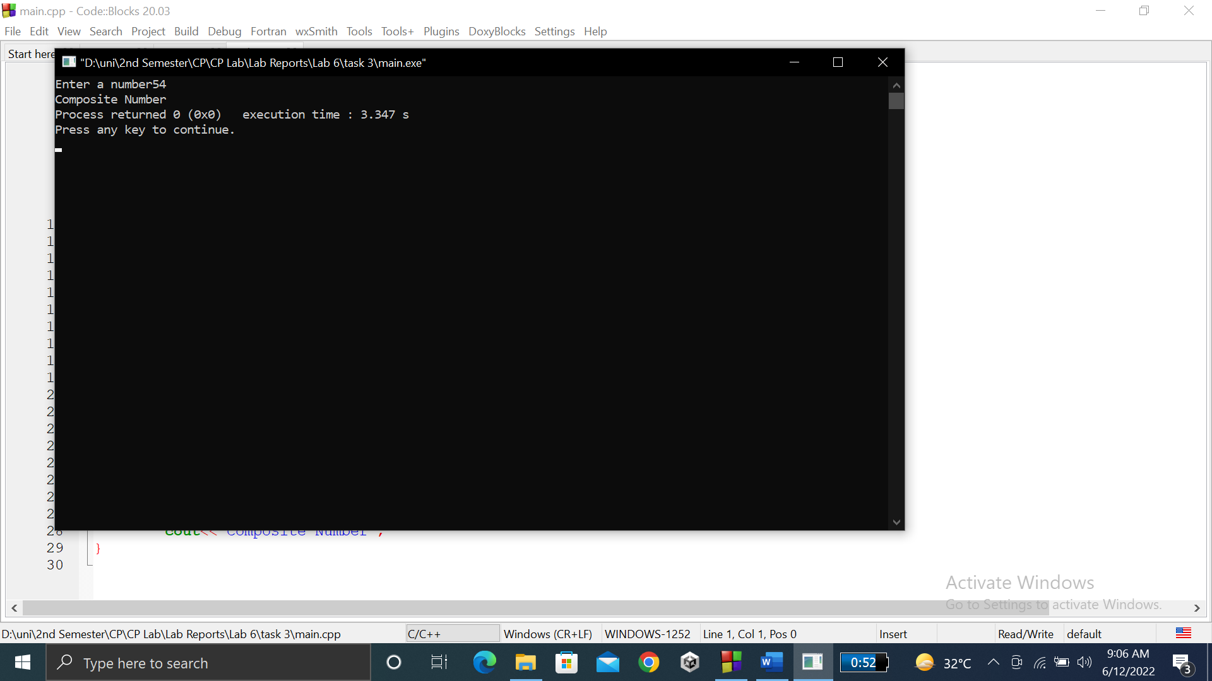

**TASK # 4:**

**Title:**

Write a program to find a factorial of user input number. Use function to find factorial.

**CODE SCREENSHOTS:**

Here is the screenshot of the code.

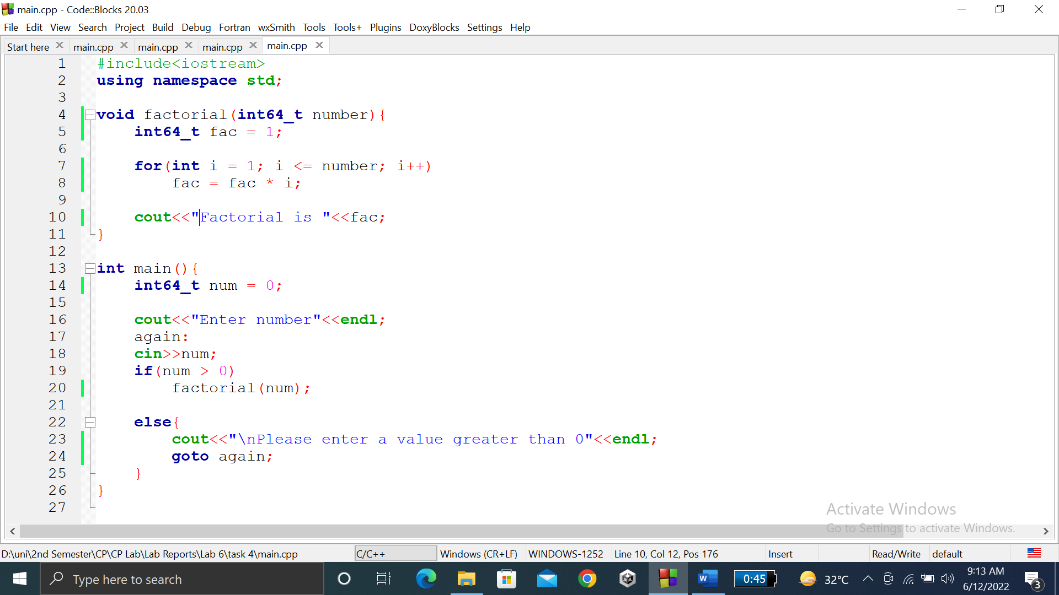

### **OUTPUT (COMPILATION, DEBUGGING & TESTING):**

Here is the screenshot of the output of above code.

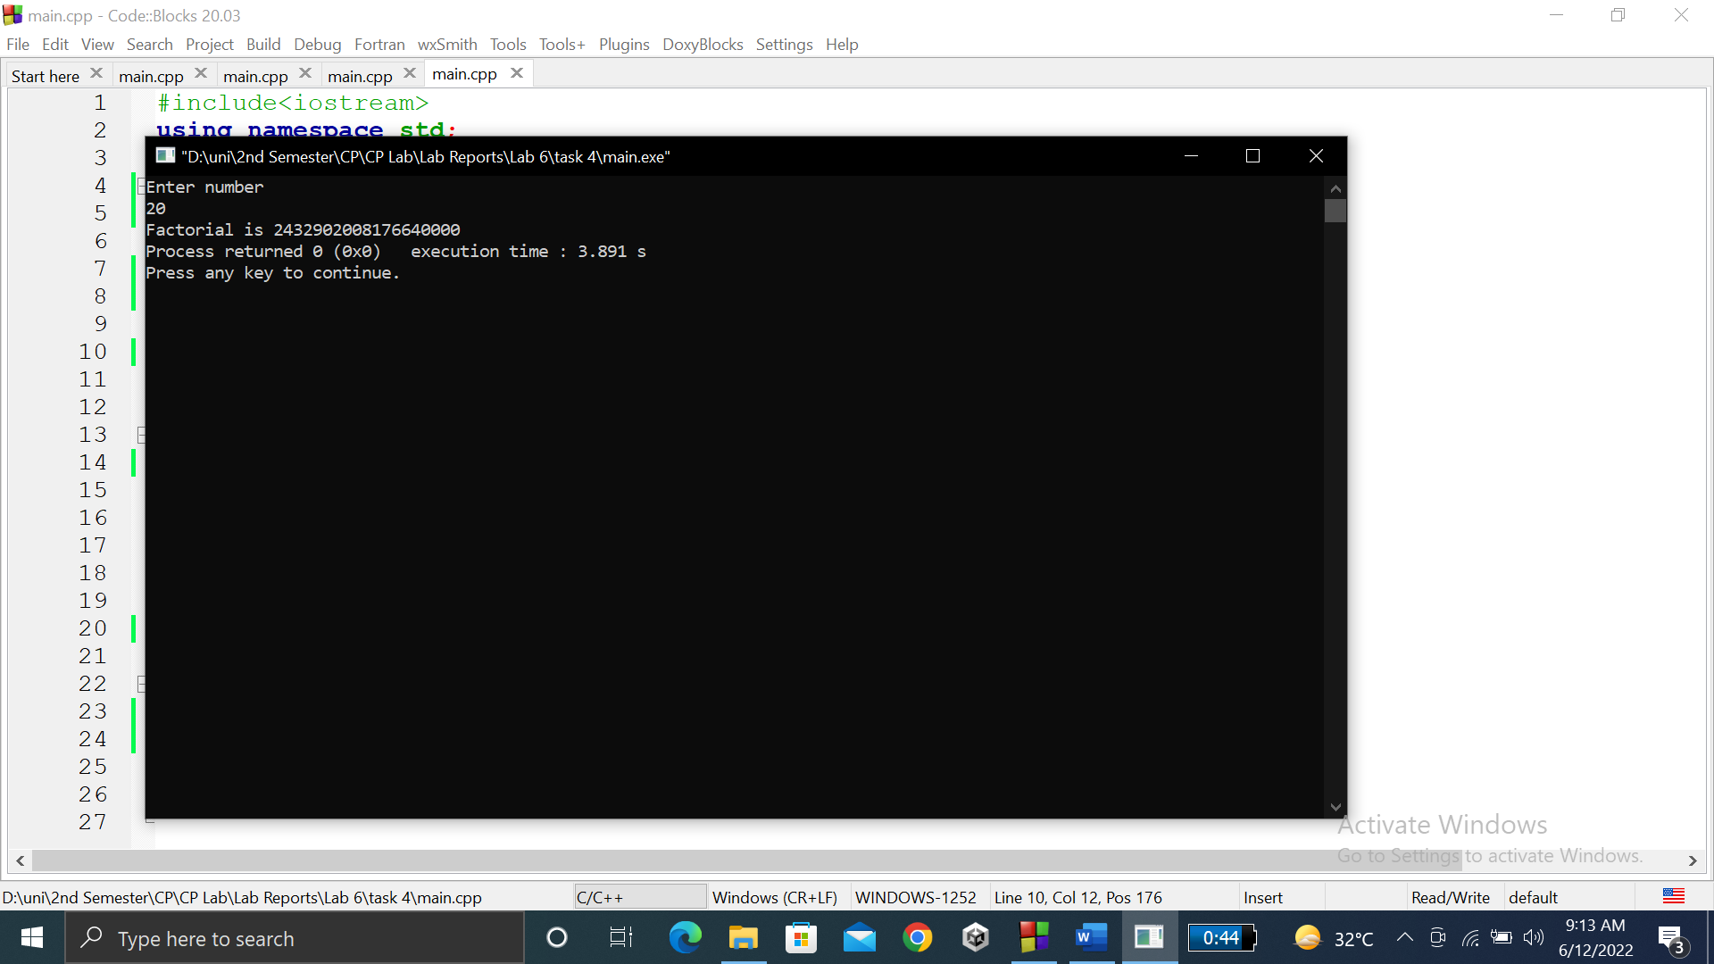

**TASK # 5:**

**Title:**

Write a program to find the roots of a quadratic……calculate d and then send the calculated d to roots() .

**CODE SCREENSHOTS:**

Here are the screenshots of the code.

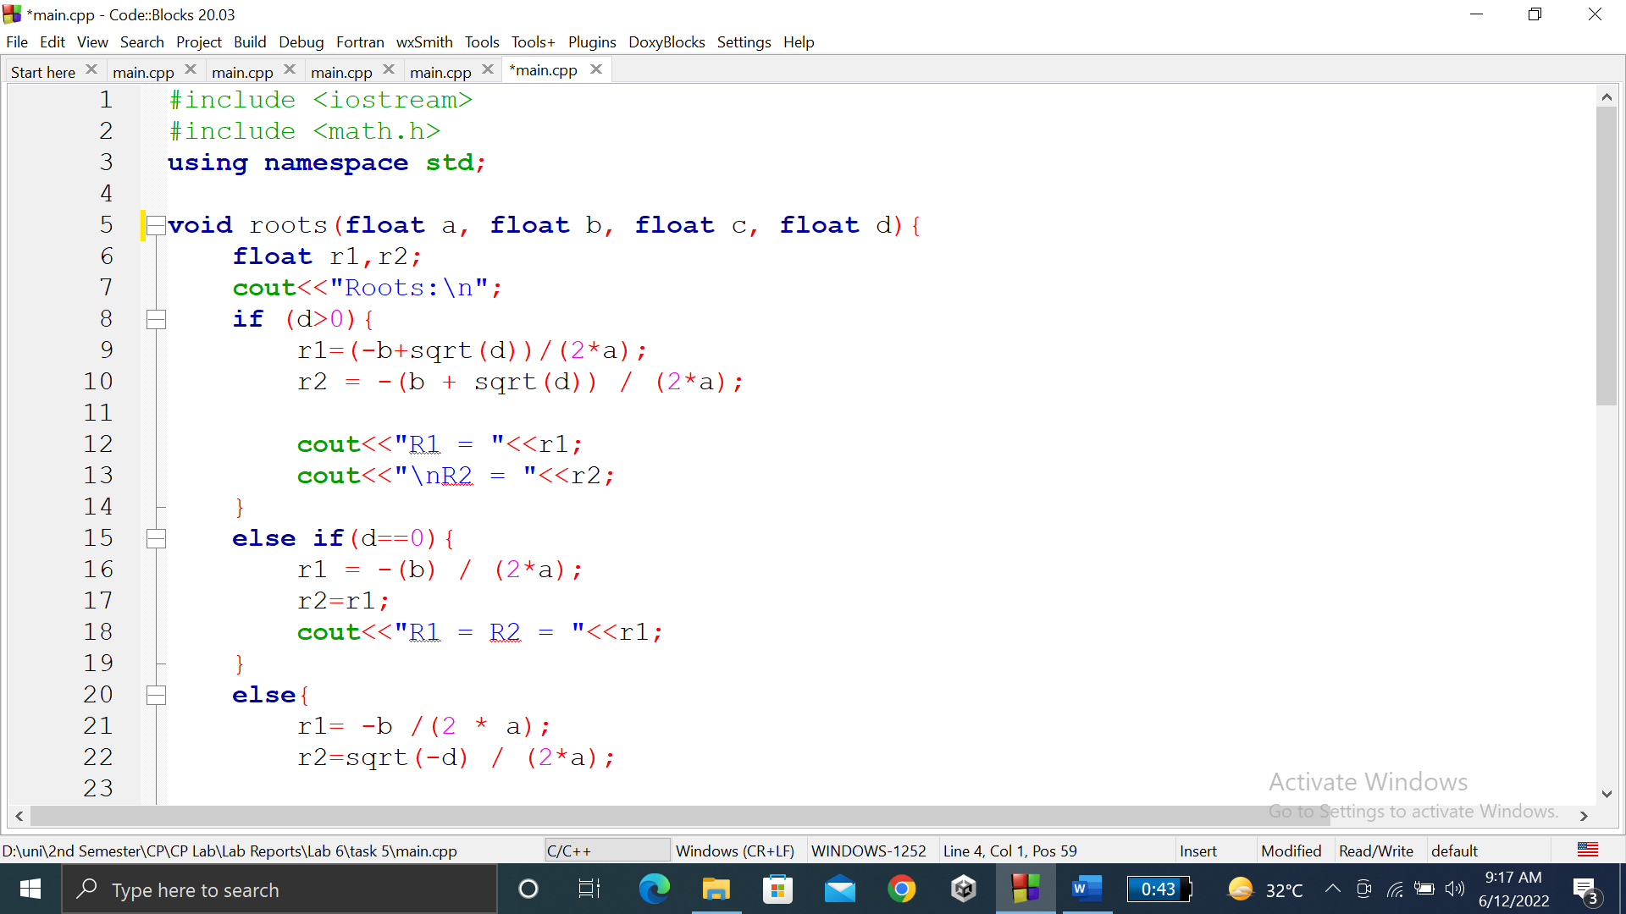

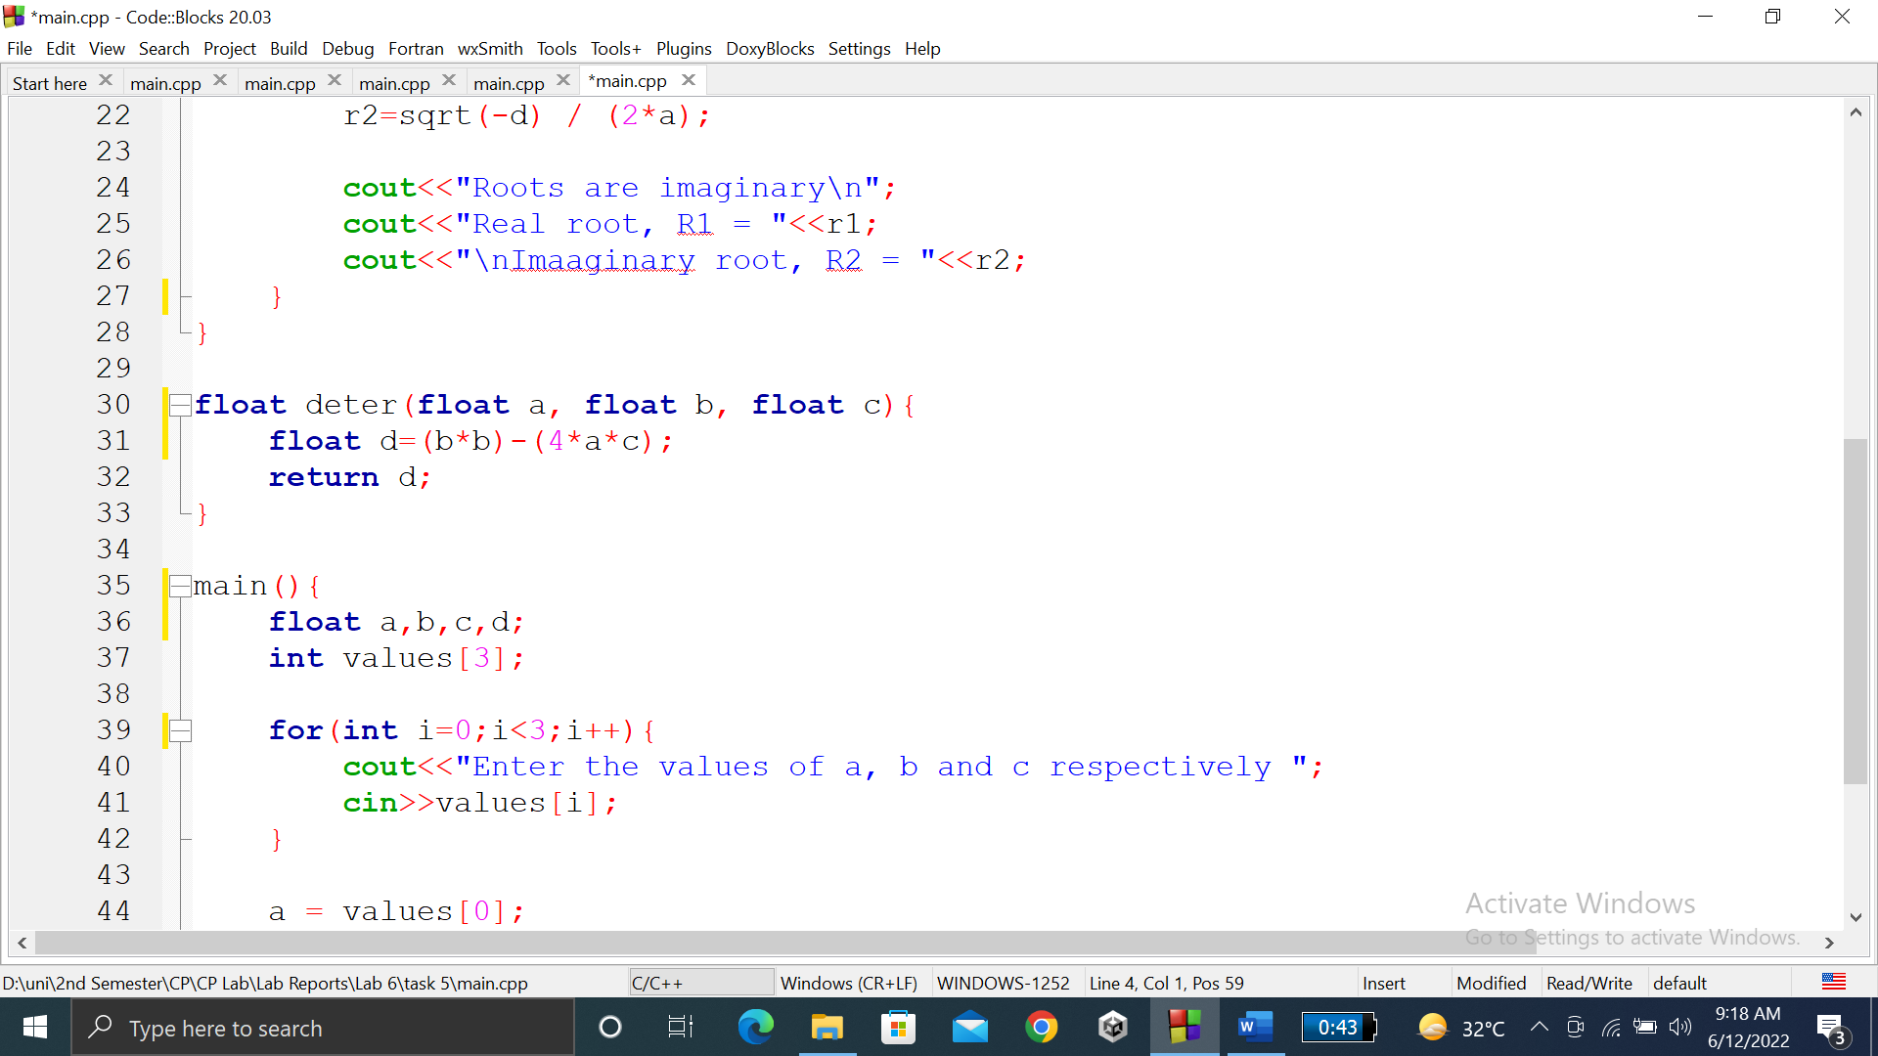

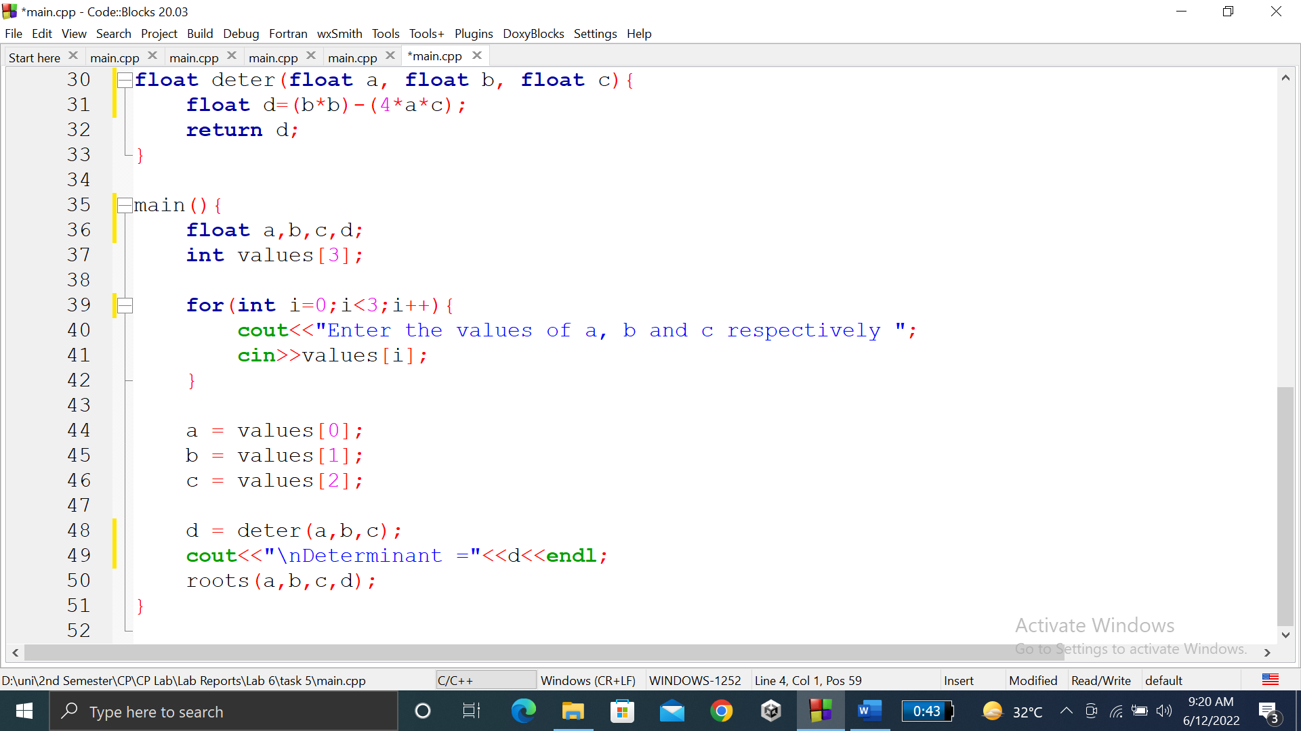

### **OUTPUT (COMPILATION, DEBUGGING & TESTING):**

Here is the screenshot of the output of above code.

